**Lab Assignment 4**

**Dataset Given**

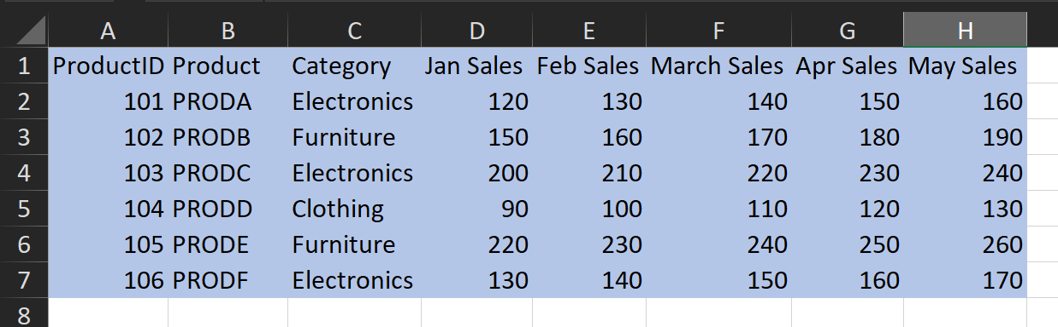

**Q1. Use INDEX and MATCH to find the sales for Product C in March.**

**Ans.** Formula Used: =INDEX(D2:H7,MATCH("PRODC",B2:B7,0),3)

Output Obtained: Sales for Product C in March = 220

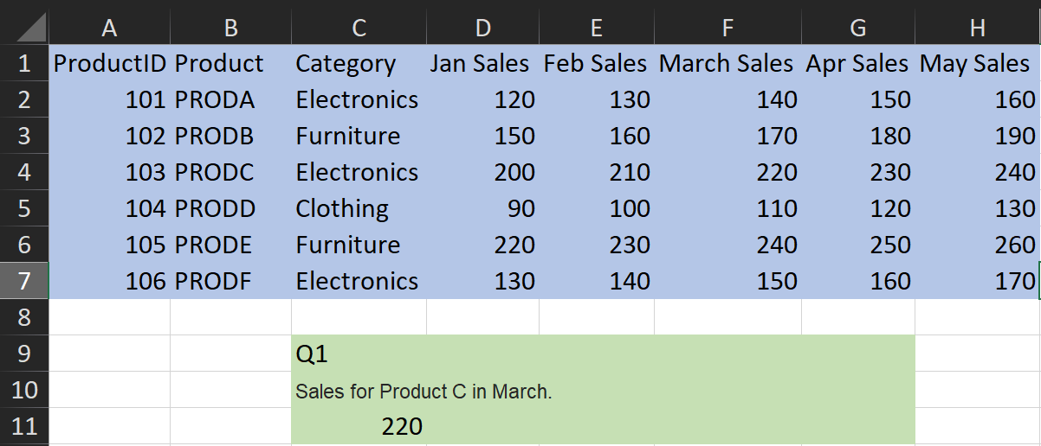

**Q2. Use INDEX and MATCH to find the category for Product E.**

**Ans.** Formula Used: =INDEX(C2:H7,MATCH("PRODE",B2:B7,0),1)

Output Obtained: Category for Product E = Furniture

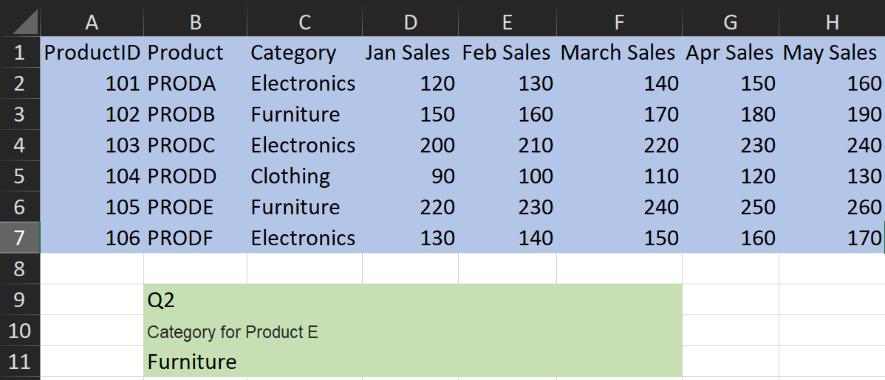

**Q3.  Use INDEX and MATCH to find the maximum sales for Product B across all months.**

**Ans.** Formula Used: =MAX(INDEX(D2:H7,MATCH("PRODB",B2:B7,0),0))

Output Obtained: Max Sales for Product B across all months = 190

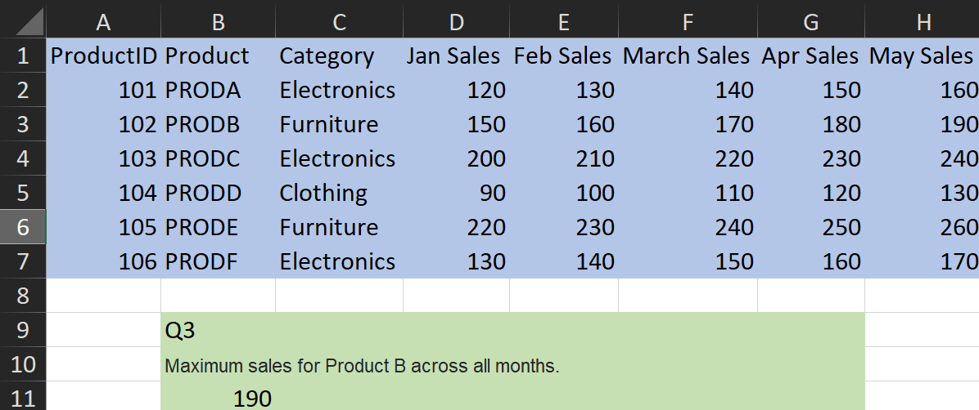

**Q4.  Use INDEX and MATCH to find the month with the maximum sales for Product A.**

**Ans.** Formula Used: =MAX(INDEX(D2:H7,MATCH("PRODA",B2:B7,0),0))

Output Obtained: Maximum sales were made in the month of May for PRODA = 160

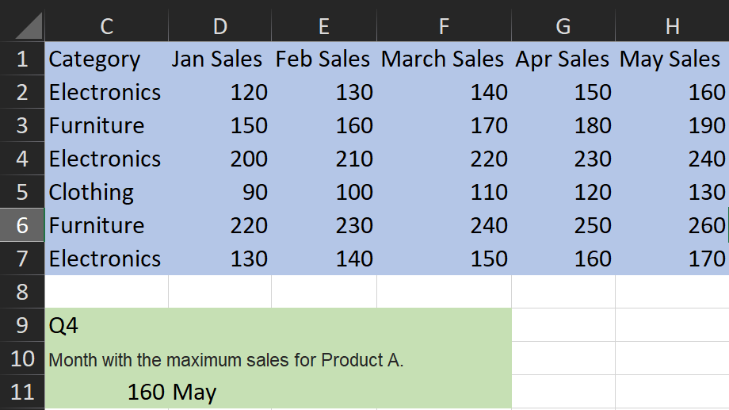

**Q5.  Use INDEX, MATCH, and SUMIF to sum the sales for all products in the "Electronics" category for April.**

**Ans.** Formula Used: =SUMIF(C2:C7,"Electronics",INDEX(D2:H7,,MATCH("Apr Sales",D1:H1,0)))

Output Obtained: Sales of Electronics category = 540

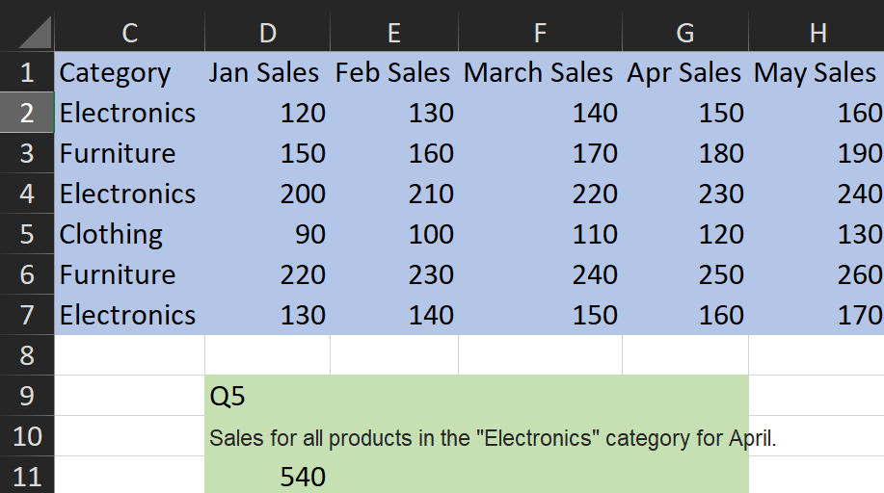

**Q6. Use INDEX and MATCH to calculate the average sales for Product D across all months.**

**Ans.**  Formula Used: =AVERAGE(INDEX(D2:H7,MATCH("PRODD",B2:B7,0),1),INDEX(D2:H7,MATCH("PRODD",B2:B7,0),2),INDEX(D2:H7,MATCH("PRODD",B2:B7,0),3),INDEX(D2:H7,MATCH("PRODD",B2:B7,0),4),INDEX(D2:H7,MATCH("PRODD",B2:B7,0),5))

Output Obtained: Average sales for product D across all months = 110

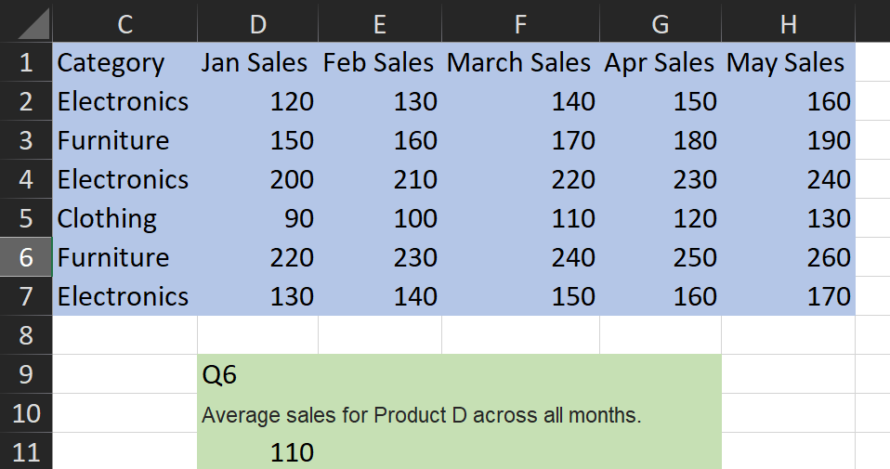

**Q7. Use INDEX and MATCH to find the sales for Product ID 105 in May.**

**Ans.** Formula Used: =INDEX(D2:H7,MATCH(105,A2:A7,0),5)

Output Obtained: Sales in May for Product ID 105 = 260

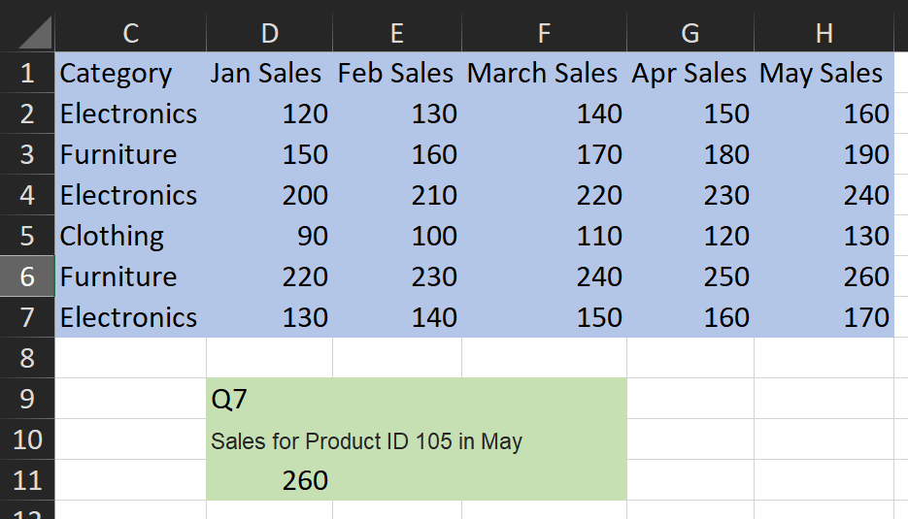

**Q8. Use INDEX and MATCH to create a dynamic lookup where the user can input a product and a month, and the formula returns the corresponding sales.**

**Ans.** To make the lookup dynamic, we use the data validation feature to allow various inputs without manually changing the formula again and again.

Formula Used: =INDEX(D2:H7,MATCH(C12,B2:B7,0),MATCH(D12,D1:H1,0))

Output Obtained: Example = PRODD Apr Sales = 120

